**Software developer: Carol He**

1. **Files worked on in Desktop application**

Codes in the Product Region in Form1.cs:





AddUpdateProduct Form:



Product entity class and DB classes:



Validator for Controls on Product Tab:



1. **Files worked on in Web application:**

Most of the entity classes and DB classes:

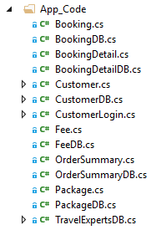

OrderSummary Page:



Logout Page:



Header and Footer in Master page:



Header and Footer Style Sheet and OrderSummary Style Sheet:

